**Table of Contents**

Chapter I: Introduction1

Chapter II: Overview of the Project2

Chapter III: Scope3

Chapter IV: Diagrams

Star Schema4

Table Definitions5

Flowchart6

Data Flow Diagram12

Hierarchical Input Process Output13

Use Case Diagram14

**CHAPTER I**

**INTRODUCTION**

Grading system, a standardized measurement for various degrees of accomplishment in a course, is the process of grading in education. In general, grading systems are used by educators to assess student performance on standard scales, which are based entirely on points and comprise grades like A-F or ranges like 1-10; typically, letters and numbers are used to denote the grades of students. The grading system's purpose is to provide students with feedback so they may take control of their learning.

Some universities in the Philippines use a 5-Point Scale. In this system, a grade ranges from 1.00 to 5.00, with 5.00 denoting a failing grade and 1.00 the highest, as well as a curriculum weighted average. For Senior Highschool level and below, a uniform and competency-based grading scheme is used in the K–12 Basic Education Program. The weighted raw score of the students' summative assessments will serve as the basis for all grades. The advantage of a grading system is that it will reduce the misclassification of students based on their grades. High achievers won't engage in toxic rivalry anymore. The student will have more freedom and less social pressure as a result. It will result in an emphasis on creating a better learning environment.

**CHAPTER II**

**OVERVIEW OF THE PROJECT**

The proponents focus on developing and designing the proposed system, Helping Junior High School departments to have their software for the grading process, the proposed system is a grading system that would be able to manage by the teachers and students. A Grading System can assist in creating standards in grading to meet the specific requirements of an institution.

The developers provide an advanced software of grading system that can benefit the Junior High School Department. through this system, The Junior High School department can be able to experience a better and more rapid process when it comes to grading. In addition, they can be able to replace the traditional way of grading a student with an advanced system.

**CHAPTER III**

**SCOPE**

Login Module – This module checks the username and password, then redirect the user to access the modules.

Grades Module – This module is what the teachers can access, and it is where they can input the grades of each student that they teach. This is also where they can import and export the gradebooks an export grade cards for the students. This module also generates a grade report.

Assistant Teacher Module – This module is where the assistant teacher can view the grades of each student and the grade reports.

Registrar Module – This module is where the registrar can add students, teachers, assistant teachers, subjects, and sections. It enables the registrar to assign sections to student and assign subject/s to teacher/s and students. It also generates an enrollment report.

Admin Module – This module is only for the admin; this module has access to all the modules and reports. This module is where the admin can add a registrar.

**CHAPTER IV**

**DIAGRAMS**

**Star Schema**

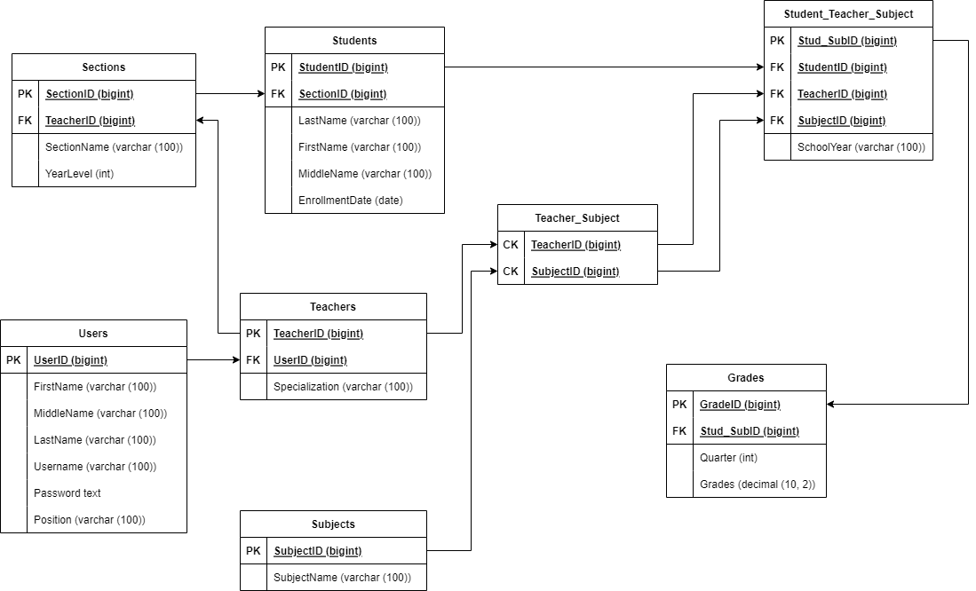

Figure . Star Schema

**Table Definitions**

The table definition defines the database objects that contain all the data in the database of our system. The primary key data type that is used for our table is mainly big integer and the variable character data type that we use has 100 maximum characters.

The Users table consist of UserID that serves as the primary key for the table, first name, middle name, last name, username, position of the user that is in data type variable character. And lastly, the password as text data type.

The Teachers table consist of TeacherID as the primary key for the table. The Teachers table has a foreign key UserID from the primary key UserID in Users table. Lastly, is the Specialization with a data type variable character.

The Sections table consist of SectionID that serves as the primary key for the table. The Sections table has a foreign key TeacherID from the primary key TeacherID in Teachers Table. SectionName that is in variable character data type. And YearLevel with a integer data type.

The Students table consist of StudentID as the primary key for the table. The Students has a foreign key SectionID from the primary key SectionID in Sections table. Last name, First name, and Middle name with a variable character data type, and EnrollmentDate with a data type date.

The Subjects table consist of SubjectID that serves as the primary key for the table and, SubjectName with a variable character data type.

The Teacher_Subject table has two (2) composite key columns. First is the TeacherID from the TeachersID table. And the SubjectsID from the Subjects table.

The Student_Teacher_Subject table consist of Stud_SubID as the primary key. The Student_Teacher_Subject has three (3) foreign key columns. StudentID from the primary key StudentID in Students table, TeacherID from the primary key TeacherID in Teachers table, and SubjectID from the primary key SubjectID in Subjects table. It also has a column SchoolYear with a variable character data type.

The Grades table consist of GradeID as the primary key. The Grades table has a foreign key Stud_SubID from the primary key Stud_SubID in Students_Teacher_Subject table. It also consists of Quarter with a integer data type and Grades with a decimal format 10, 2 data type.

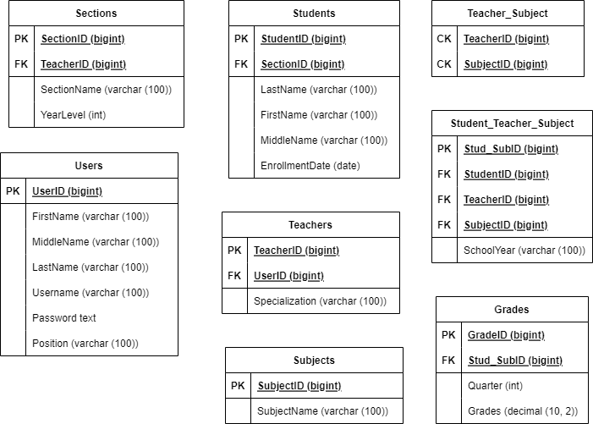

Figure . Table Definitions

**Flowchart**

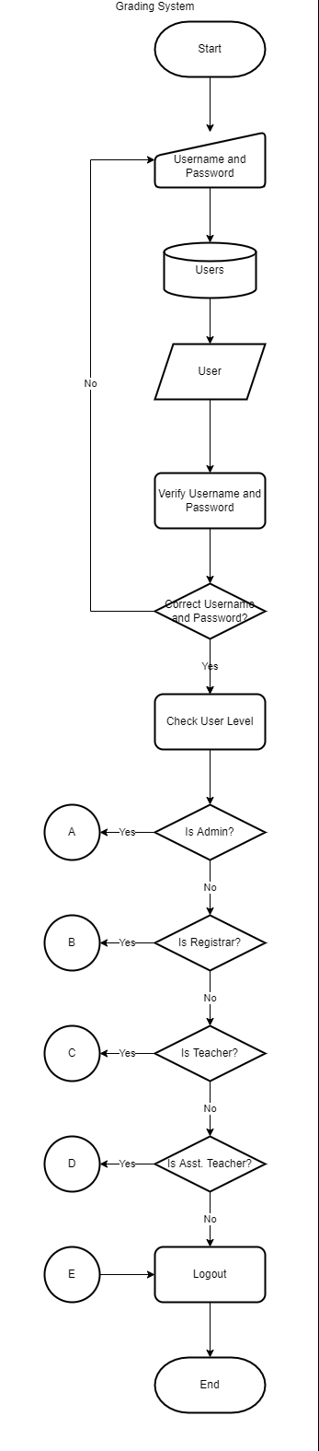

Figure . Grading System

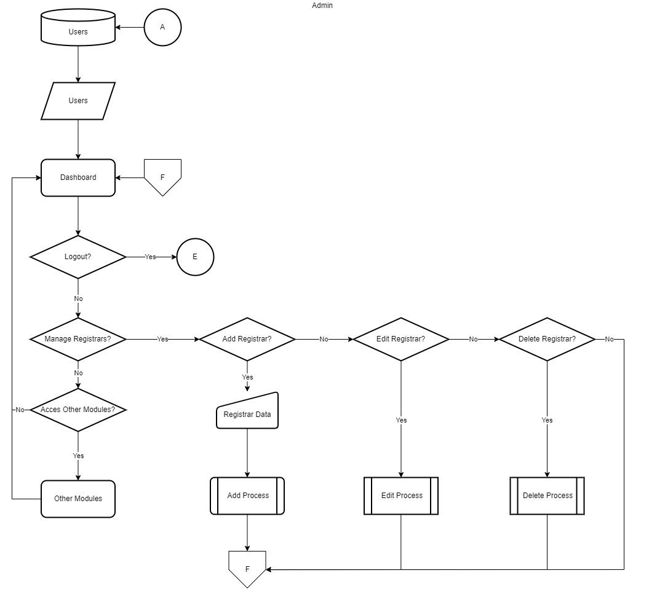

Figure . Admin Module

Figure . Registrar Module

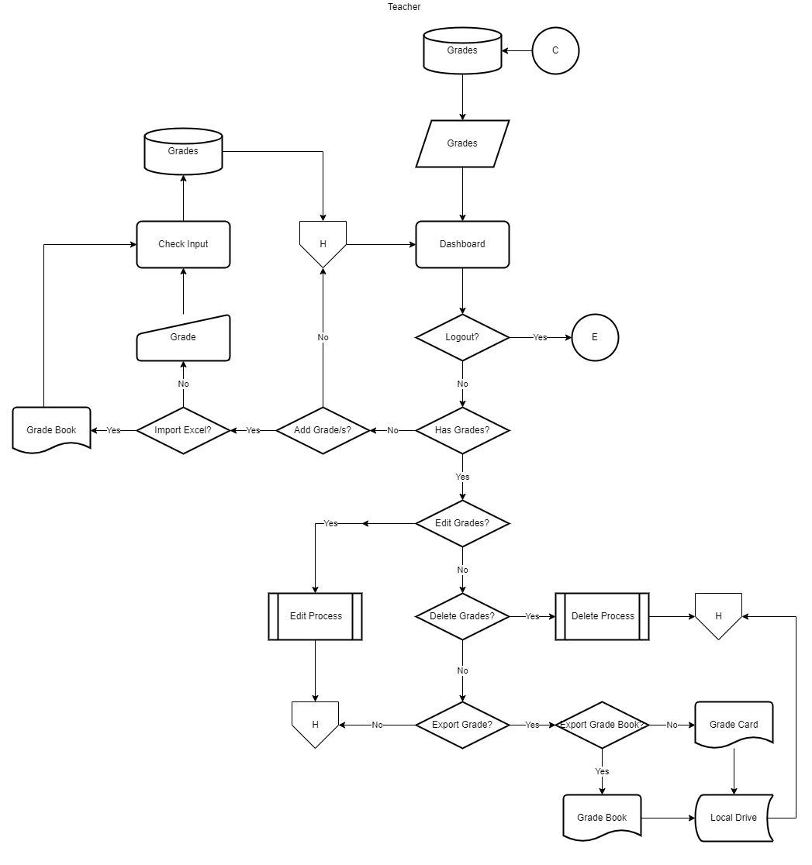

Figure . Teacher Module

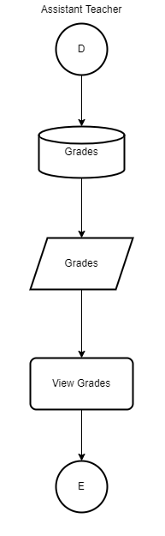

Figure . Assistant Teacher Module

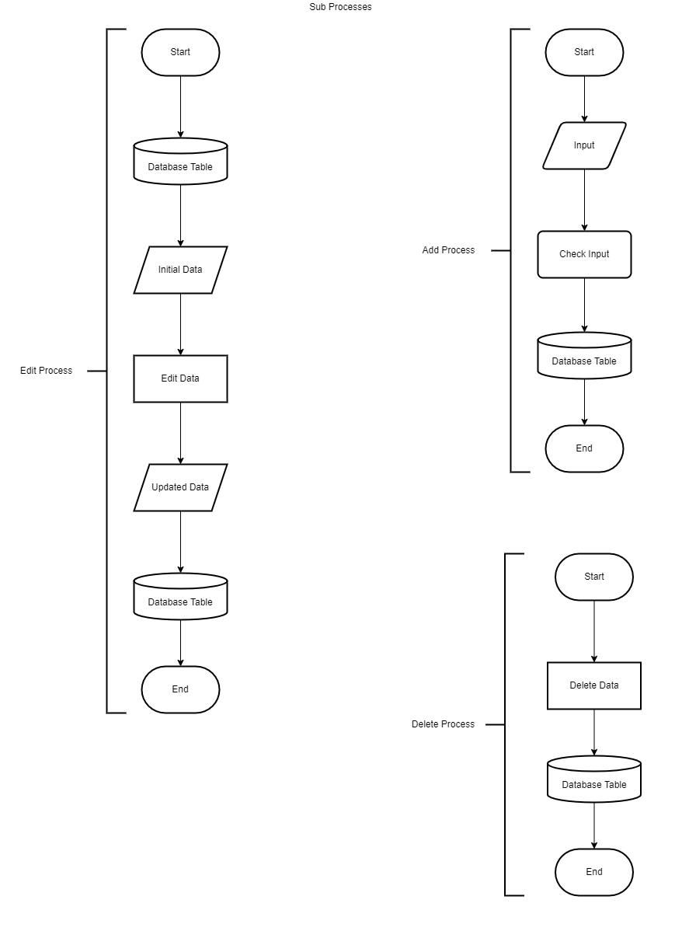

Figure . Sub-Processes

**Data Flow Diagram**

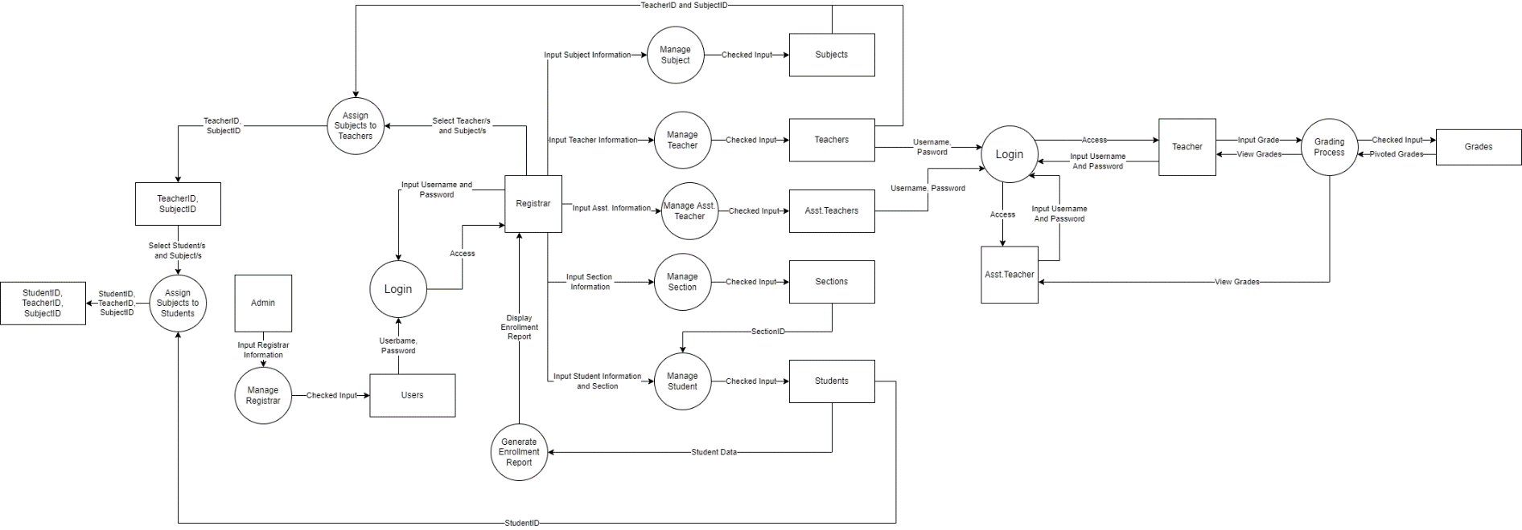

Figure . Data Flow Diagram

**Hierarchical Input Process Output**

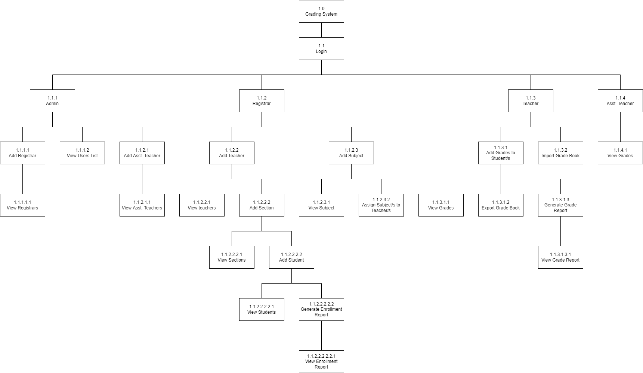

Figure . Hierarchical Input Process Output

**Use Case Diagram**

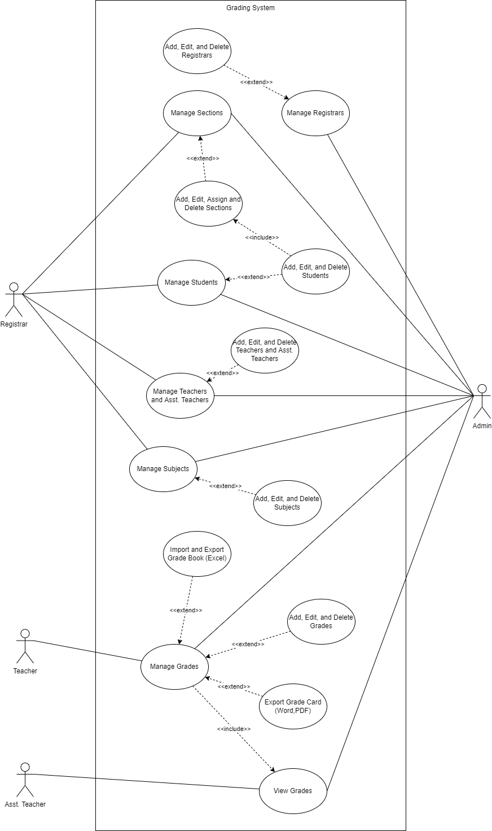

Figure . Use Case Diagram